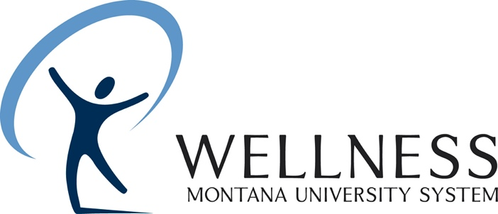

MUS Photo Release Form

Date:

Event:

Picture Description:

I hereby grant Montana University System Wellness permission to interview me and/or use my likeness in photograph(s) in any and all of its publications and in any and all other media, whether now known or hereafter existing, controlled by Montana University System Wellness, in perpetuity, and for other use by the Wellness Program. I hereby release Montana University System Wellness and any photographer chosen by Montana University System Wellness to photograph me from any and all claims for damages for libel, slander, invasion of privacy or any other claim based upon the use of my photograph and information about me for this purpose.

Subject’s Name (print full name):

Signature: _________________________________________

Address:

City, State, Zip code: Telephone:

